

Final Report

of **Group Project**

by

**Group number** **1**:

Hongjie cui (5174523)

Haokang Deng (3456357)

Yu Fu (5223014)

Tian liu (5230310)

hang su (5109206)

Zhiyu tao (5188980)

minyuan yang (5144141)

zhe zhang (5185575)

time due: 6:00 pm 9th august 2019

GSOE9820 – Project Management – T2 2019

School of Mechanical and Manufacturing Engineering  
The University of New South Wales

Executive Summary

For project management, our team had divided the whole project into six parts which include project selection, scope of work, work breakdown structure, budget and schedule, resource planning and risk management. The main parts of our project are:

Scope of project is the preparation phase.

Work breakdown structure is the most important part in this project, in this part, our team focus on how to complete the whole project in order, so we divide into some phases. So we can focus on one thing in a time and ensure we can finish this project on time.

Budget and schedule can guarantee our project on schedule. Followed by resource planning and risk management, these two parts make sure we assign appropriate resource to a specific part, and we have plans to deal with some problems when the project on process.

Contents

1. introduction 1

2. Project selection 2

3. scope of work 3

4. Work breakdown structure 4

**4.1 Deliverables and its coding 4**

**4.2 Organization Breakdown Structure 6**

**4.3 Integrated WBS and OBS 6**

**4.4 An example of one work package from WBS with its corresponding activities. 6**

5. Budget and schedule 8

6. resource planning 9

7. risk management 10

8. Conclusion 11

9. References 12

Appendix 13

# introduction

Our project is Charity Gala Dinner, and our team will help non-profit organisation “Students 4 refugees” run by students to organise this project on the 14 August 2019, at Tyree Room and Alumni Terrace (UNSW Kensington).

The purpose and the aim of our project is to fundraise and raise awareness of the world refugee crisis and we will create kits, which can be provided to refugees living in camps. And the kits we need to create will provide essential items, which are needed by the refugees at the camps, including toiletries and sanitary products, water filter funnels, blankets and so on.

The goal is to establish connections in these regions to eventually go and visit the camps to witness and observe the situation first hand. The charity gala event is being hosted to raise funds, network and promote the project.

# Project selection

Project selection is one of the essential elements in any organisations. It ensures a correct pathway to start the project. Usually a portfolio management system is used to ensure the correct strategic goals and priorities. In this charity project, the major goals that must be met are to raise money to at least $1,200, to gain team experience in project management and to comply with the university safety policies. These three objectives must be aligned. If one of these is fail to meet, this project will be rejected. Therefore, based on the proposals for the six potential projects including Big Sleep-out Under the Stars, Green Thumbs Up, Movie Night Networking, Charity Gala Dinner, Raffle for Life and Men Futsal Competition, most of them can meet the Must-Objectives except Big Sleep-out Under the Stars. This project could not meet the $1,200 raising limit that is shown in Appendix Table 1, so it would be neglected. In order to estimate the total value for each project, the sources of donation and cost were obtained. Some of the data was given and the missing one would assumed by common sense and researched. For other Must-Objectives, all the project will gain on hands practices of project management and all the event will be complied with the University policies and safety regulations.

After considering the Must-Objectives, there are several Want-Objectives that need to consider. Firstly for the raising potentiality, the Green Thumbs Up project has a low potential to raise above $1,200 because of the uncertainty of likeness to the handmade products. The Movie Night Networking had the same issue, which depends on the Bollywood movie lover. However most of the group member were not familiar to Bollywood movie. It will reduce the passion and priority to this project. The Men Futsal Competition was relatively easy for registration of 8 teams, but fundraising sources would be depended on selling the T-shirt. The other Charity Gala Dinner was potentially obtain the limit because of the high level of participators. And Raffle for Life had a minimum limit, which was also easy to achieve. Secondly the ability to complete within 7 to 8 weeks, it was considering to be all passed for all projects. For the request for waiver of liability, only the Men Futsal Competition would be required. For the request for copyright license, the Movie Night Networking is the only one is required. Most of the project can provide the opportunity of exposure to gain sponsorship and marketing experience, resume worthy experience and increase awareness of charity, except the Movie Night Networking and Raffle for Life have low potential to reach this objective. And finally and most personally, team members thought these projects would be fun in an intermediate feeling reaction.

And the strategy is using the Multi-weighted scoring model. The columns in the Appendix Table 2 are showing all of the calculated weighted scores based on the evaluation of the team. The final score for each project is located at the bottom, which is the sum of the given relative importance times the weighted score of the potentiality to meet each objectives. During the team evaluation, each team member set different point score for each project, however the priority for each projects were the same. As the result, the Charity Gala Dinner got the highest score in the team evaluation, which was selecting as the topic for the Charity group project.

# scope of work

After project selection, our team finally decide the topic of Charity Gala Dinner. This project will establish connections in these regions to eventually go and visit the campus to witness and observe the situation first hand. The obvious benefits of this project are that it can fundraise and raise awareness of the world refugee crisis which is a tough problem over the world. To complete this project, Kits will be collected, which can be provided to refugees living in campus. The charity gala event is being hosted to raise funds, network and promote the project where donations are accepted to create kits for refugees (i.e. toiletries and sanitary products, water filter funnels. Blankets etc.). In addition, we also need to prepare plenty of essential items which are needed by the refugees at the campus.

As the aspect of hardware, for the banquet, our team need to prepare 160 seats which can make sure a lot of people’s participation. After that, suitable numbers of tables, chairs, tableware, temporary stage and audio-visual devices should be prepared. For the music player, a laptop, projector, and a loudspeaker box is important. Moreover, dinner tools are also significant. Knives, plates, forks, chopsticks should be prepared and keep clean. Food purchase list should be made, and we also need to arrange stage show for the dinner banquet.

Additional cost would be used on tickets including designing and made. As the aspect of software, in other words, for technical requirement, three or more video equipment are required to record this dinner. For promotion purpose, these video and photos could be posted on the social media to expand the influence of the dinner. At the time of the dinner, one projector and a large screen should be there in order to demonstration ppt or something. Lighting equipment is required for holding the dinner and make sure the effect of the performance of stage. The first step is to make a budget list to clarify what items should be prepared. At the same time, our project manager could make a basic project plan and discuss with group members. After the discussion, we should send a budget list, which clearly write down the cost of each item or activity to the customer and sponsor. As long as they agree with our project, group member could start to prepare these things. The second step is to hand in basic plan to them, make them clear the direction of the next step for high efficiency of the group-work. Some of our group would take responsibility to the location available for the project, avoid crash with other events. If all of above are accepted by customers, customer should sign-off on contract. During the work of these project, we have found a lot of limitation and challenge in it. To make sure the equality, the categories of dishes cannot be too much. Due to the location is a kind of indoor field, the categories of activities are restricted in a small range. After checking UNSW official website, Tyree Room and Alumni Terrace is just available for 140 people inside, that means we need to prepare additional seats for the dinner. Because of the confusing traffic nearby, we also need to make special maps or posters, labels to guide direction of Tyree building. Although there are a lot of potential challenge around the project, our team is already do our best to overcome it through communicating with UNSW and the customer.

# Work breakdown structure

Work breakdown structure (WBS) is a good tool which break down the whole project into manageable parts. It outlines the project with different levels of details in a diagram. To make WBS clear and tidy, the high level of information is kept in the structure. The details of the activities are skip in WBS, while it will be contained in work package.

## 4.1 Deliverables and its coding

To realize the goal of raising fund, the project was divided to deliverables and sub-deliverables. Its level and corresponding coding are presented below.

Where the level 1 is orange, level 2 is yellow, level 3 is green, level 4 is purple and level 5 is blue.

Figure 1

The numeric indention of Figure 1 are presented below:

1 Charity gala dinner project

* 1. 1.1Market strategy
     1. 1.1.1Sponsorship
     2. 1.1.2Marketing
        1. 1.1.2.1Advertisement
           1. 1.1.2.1.1 Poster
           2. 1.1.2.1.2 Broadcast
        2. 1.1.2.2 Ticket
           1. 1.1.2.2.1 Ticket Design
           2. 1.1.2.2.2 Box office
  2. 1.2 Venue
     1. 1.2.1 Venue Set-up
        1. 1.2.1.1 Venue Booking
        2. 1.2.1.2 Table and Seats set-up
        3. 1.2.1.3 Stage Decoration
     2. 1.2.2 Audio and Light
        1. 1.2.2.1 Audio Set-up
           1. 1.2.2.1.1 Audio Device Control
        2. 1.2.2.2 Light Set-up
           1. 1.2.2.2.2 Light Performance Design
           2. 1.2.2.2.2 Device Control
  3. 1.3 Dinning
     1. 1.3.1 Table ware
     2. 1.3.2 Dinning design
        1. 1.3.2.1 Menu Design
        2. 1.3.2.2 Material Purchase
  4. 1.4 Closure
     1. 1.4.1 Venue Clousre
        1. 1.4.1.1 Return borrowed item
        2. 1.4.1.2 Clean up the Venue
     2. 1.4.2 Rasied fund calculation

## 4.2 Organization Breakdown Structure

Organization Breakdown Structure (OBS) is the arrangement about how the responsibilities are assigned or organized. It is a structure about departmental information about the team arrangement according to the deliveries and sub-deliveries of the project. The diagram of OBS in this project are illustration below.

Figure 2

4.3 Integrated WBS and OBS

Figure 3

Every lowest delivery of every branch match up the part of OBS. The arrows show how the tasks were assigned to the different departments, which also shows the responsibilities of each departments of the whole team. Then the cost account can be decided at where it will take a cost.

## 4.4 An example of one work package from WBS with its corresponding activities.

According to the format provided in the lecture material, the deliverables and estimated budget were filled in the blank.

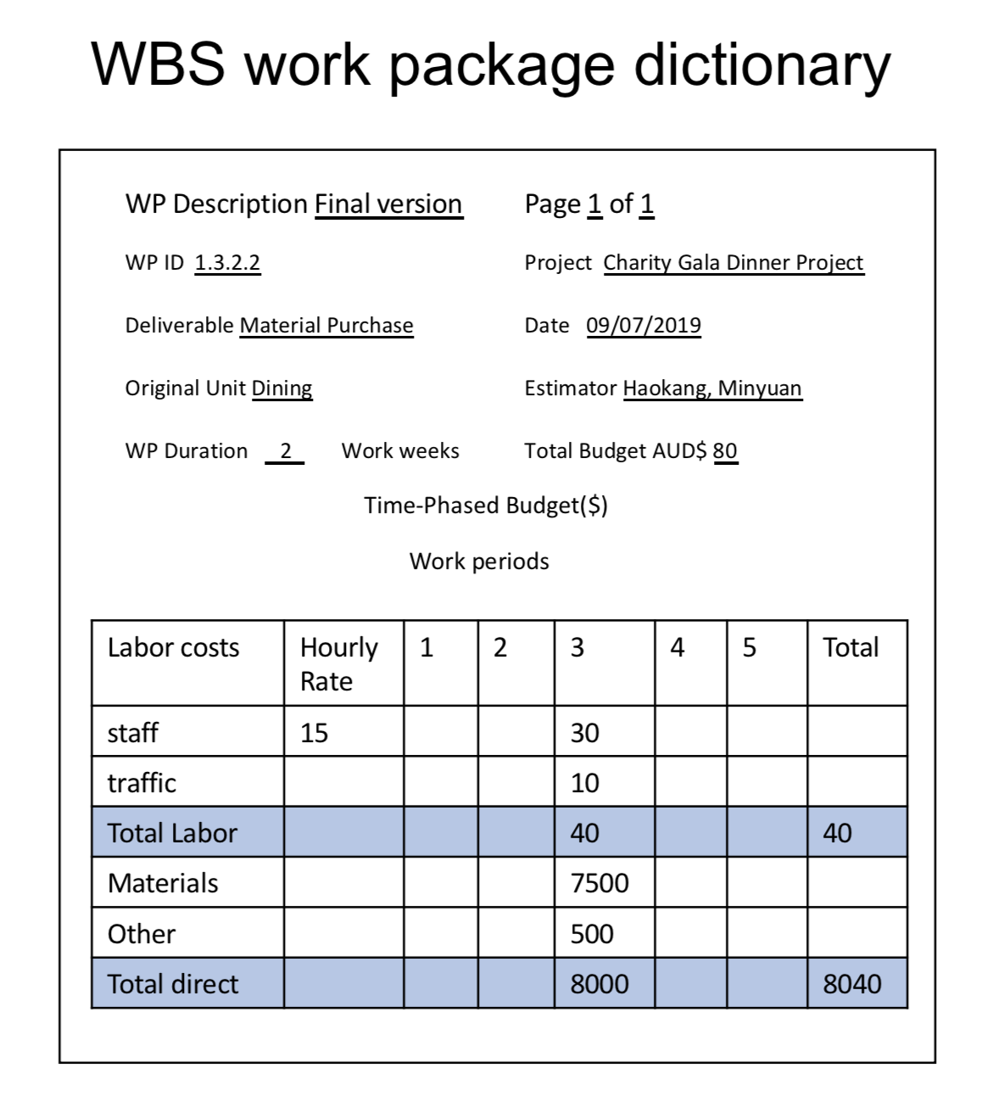

Table 1

# Budget and schedule

In a project, budget and schedule are the critical factor to the successful implementation of a project. According to [Dov Dvir](https://www.sciencedirect.com/science/article/abs/pii/S0263786302000121" \l "!) (2003, *International Journal of Project Management*), “project success is positively correlated with the investment in requirements’ definition and development of technical specifications”. Whether the estimation of the budget needed for a project is accurate and whether the fund is sufficient to support the project completion determines the success or failure of the project to a large extent， and an accurate and detailed schedule allowed the participants to have a clear understanding of the entire process of the project. It also helps the project manager to recognize the current progress of the project and make some adjustments to the project in time to avoid some risks and to manage the project team better.

As shown in Figure 4, for the Charity Gala Dinner, by calculating, the total cost of the whole project could be obtained which is 12395 dollars. The entire process of this project is divided into four parts which includes market strategy, venue, dining and closure. Eight different events could be obtained from the further division of these four parts. Almost every event could be divided into several small events and the events in each block would cost different amount of money.

When it comes to project budget, among these four main parts, the dining part spent the most money which is 8080dollars and it accounts for about 65.51% of the total cost. The reason why it spent so much money is that the budget of purchasing and renting all the materials needed for the Gala Dinner is contained in this part, such as tables, chairs, sound system, lighting equipment and ingredients for food, the other part menu design and production need small amount of money and it only need 80 dollars and accounts 0.65%. The second most expensive part is about venue which contains venue set-up, audio and light equipment. For the audio and light set-up part, it cost 210 dollars in total and account only 1.69% of the total cost. Most of money are spend in the venue set-up part for venue renting. The venue booking would cost 2250 dollars and account for 18.15% of the total cost of the project. It is worth noting that the light equipment might be hired more than one day and the venue also need to be rent at least two days, because the venue need to be arranged in advance for the dress rehearsal purpose. sponsorship and marketing. The third most expensive part is about market strategy which includes two parts, sponsorship and marketing. For the sponsorship, the money would be cost mainly in travel expense when looking for a sponsor and it cost only 100 dollars. For the marketing part, it would cost 1440 dollars in total, advertisement and ticket would cost similar amount of money which are 700 and 740 dollars respectively. For the ticket part, a temporary box office is needed for ticket sell and the money spend in building it would cost most of money of the ticket event (86.4%). Finally, the least expensive main part is project closure which includes venue closure and raised fund calculation. Calculators and fundraising boxes making would be need for raised fund calculation. The project closure only need 195 dollars and account for 1.57% of the total cost of the project.

The figure 6 shows that the total time required for the project is about two months (60 days) and it contains 8 tasks. Among these tasks, project designing which includes the planning of the entire project and process are assigned 10 days to complete, it is not a short time but it is necessary because a clearer strategy is conducive to the smooth progress of follow-up work. Project marketing needs the most time which is 30days. The reason for assigning such a long time for it is that the Gala Dinner would need a long time to advertise to attract more people to attend this dinner, so more money could be raised. Item returning need the least time which is one day.

From these two charts, it shows that the budget required for the Gala Dinner project and the time assigned for each task is reasonable are able to achieve.

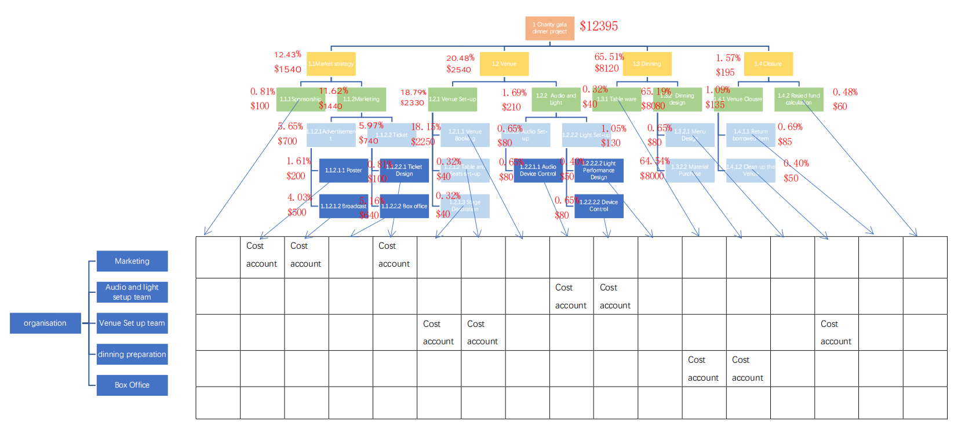

Figure 4

# resource planning

When it comes to resource planning, it is an important part with a duration covering almost the whole project. It is so important that project plan cannot be a schedule without allocated resources. According to relevant research, about 75% of projects in companies or small teams are easy to fail if resources are not well planned or managed[6.1] . It is easy to understand that the available resources include human resources, equipment and relative materials. In order to manage resource, recall from the above arrangement, the Charity Gala Dinner project is categorized into 8 parts by our group, namely project design, sponsorship, marketing, item preparation and purchasing, poster making, broadcast, venue set-up and report writing. All the resources needed are basically human resources and relevant materials (including the venue itself). Before allocating resources, it is obvious that the project is time-constrained. There is a fixed date which is 14th August, 2019. Although the total number of people available is also fixed, the resources is still flexible because apart from the report writing part, the maximum number of people in other parts of the project is 5. Even if multiple parts are carried on, the maximum number of 10 people is enough for arrangement. Besides, if the critical path of looking for sponsorship is delayed, resources would be added to make the project get back on schedule. With the following analysis, the project is time-constrained.

After figuring out the project is time-constrained, it’s time to allocate resources according to different project parts. The resource planning for each part is shown in the table below.

|  |  |  |
| --- | --- | --- |
| Project part | Number of people needed | Materials needed |
| A. Project design | 10 | 1 Computer |
| B. Sponsorship | 3 | 1 Computer |
| C. Marketing | 3 | 1 Computer |
| D. Item Purchasing | 2 | 2 item list |
| E. Poster making | 1 | 50 poster paper, 30 poster frames, glue, 1 computer |
| F. Broadcast | 2 | 20 broadcast paper, pins, 1 computer |
| G. Venue set-up | 5 | 60 sets of tableware, 6 tables, 60 chairs, 1 sound system, 1 light and control system, foods, drinks, 1 computer |
| H. Final Report | 10 | 30 documentary papers, 10 file pockets, 1 computer |

Table 2 Resource allocation table

With the resource allocation table, all the resource needed to finish the project is easy to identify and the relevant materials could be prepared in advance. After resources has been assigned to each project part, a resource loading schedule with respect to time is made to have a clear view of resource planning during the whole project. The resource loading schedule is shown below.

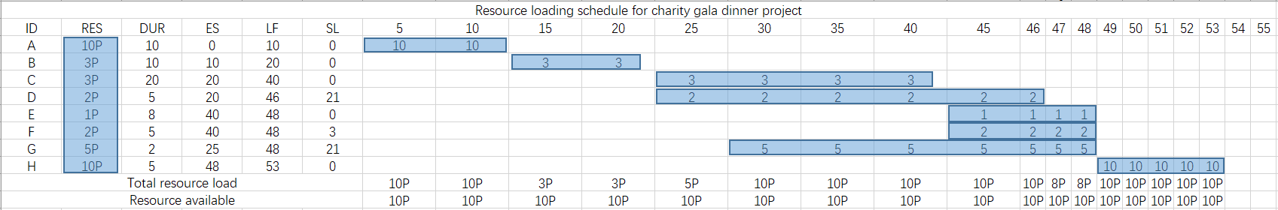

Table 3 Resource loading schedule

From Table 3, it is able to observe that the maximum 10 people is capable to finish the project by appropriate human resource allocation. Actually, in the project period, there are times when not all of group members are assigned with works. In these time periods, those people who are not assigned with works are going to be additional resources in case some project parts need more people to accomplish. By default, these people would contribute more in the report writing process and the work would be distributed evenly. With the process of resource planning done, the original project network can be updated with critical paths. The updated project network constrained by resource is shown below.

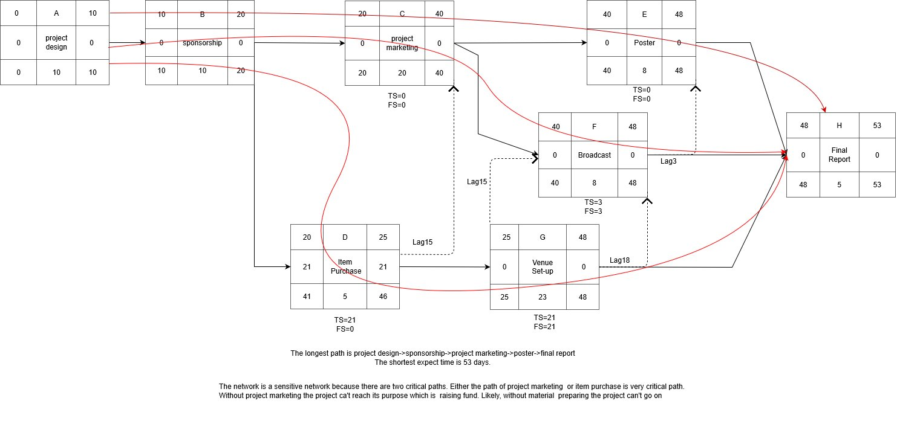

Figure 5 Updated project network constrained by resources

Apart from the above analysis, a time-phased budget and a Gantt chart are also made to have a good assumption of the budget needed and the time period for each project parts. The time-phased budget and Gantt chart is shown below respectively.

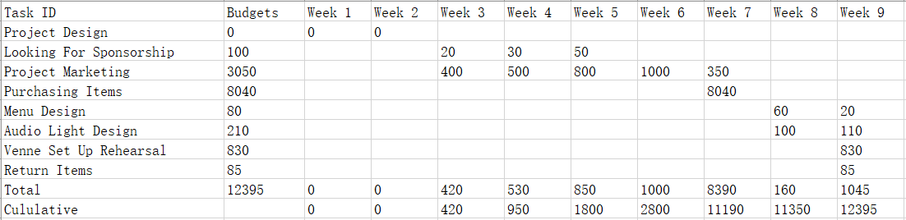

Table 4 Time-phased budget

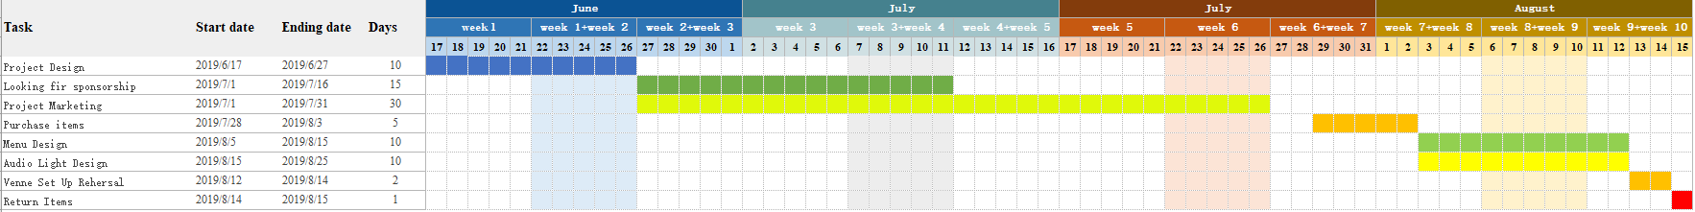

Figure 6 Gantt chart

From the above time-phased budget and Gantt chart, the project is able to be finished within the limited time period and it is a very good schedule.

# risk management

For each works in the WBS, there will be plenty of risk events in the project which can be common for all projects or particular for this project. Over the budget, loss equipment and process delay are identified as common risk events in this project. This project will provide food and shows to the guest, so there will be some risk events which are related to these, such as the safety of the guest and the performance of the show. The risk response matrix for Charity Gala Dinner project is shown below. In the next part, the risk events will be discussed from the impacts, likelihood and response.

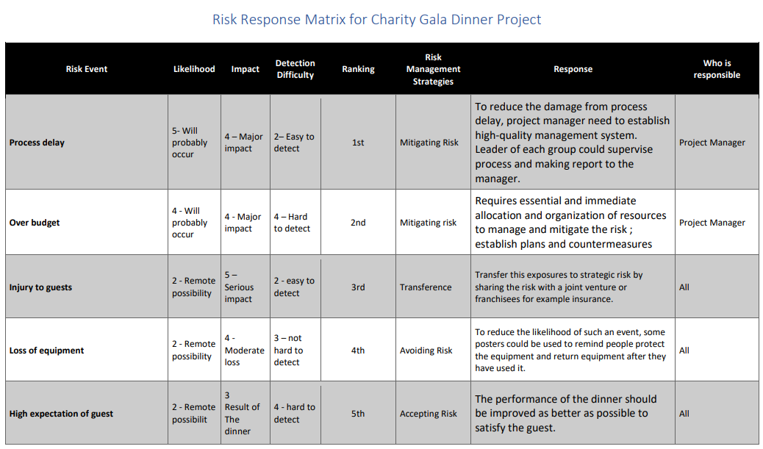

Table 5 Risk Response Matrix

To begin with process delay, one of the most common risk events in a program, it should be paid more attention and has the first rank. This event means that some works may not be accomplished on time. The impact scale will vary from the amount of work which have not been accomplished at the end of the project or when the delay is detected during the project. Besides, because there are many different and unexpected factors in the project, it is hard to avoid process delay in a project (Assaf and Al-Hejji, 2006). However, this event is easy to detect because of the schedule of each work is determined before implementation of the project. Thus, mitigation risk is used to manage this risk event. To reduce the negative effect of process delay, project manager needs to establish high-quality management system. Leader of each group could supervise process and making report to the manager.

Next to process delay, it is over budget, the final spending will be higher than budget. This will lead to additional investment or poor performance of project which has a serious impact. In addition, this will occur frequently in one project due to the variable situations and inaccurate budget and hard to detect before the project (Holzhauser, Krumke and Thielen, 2017). For this event, mitigating risk strategy is necessary. Essential and immediate allocation and organization of resources are required to manage and mitigate the risk. When it happens, countermeasures and plans will be established immediately by project manager to guarantee the completion of the project.

The risk event with third rank is the injury of guests. Some guests may be hurt in the dinner due to the unpredictable situation. This has a serious impact, because of indemnification. However, its likelihood is low if the dinner is well planned. For this risk event, transferring risk strategy is used to transferring the extra cost to insurance or a joint venture. In order to transferring the risk, security guard can be hired to protect the guest.

The fourth rank is the loss of equipment. In the project, some equipment may be damaged by uncareful use and lost because of lacking management. All the equipment is easy to use in this project and will not be used for a long time, so this event has remote possibility. If it happens, extra money will be spent to fix or buy the equipment. This may cause process delay or over budget. As mentioned before, it can be managed by avoiding Risk. The proper method of using equipment should be confirmed in advance and all equipment need to be well managed by all team members.

The last risk event is high expectation of guest. Because the interests of guests are uncertain, not all the guest will prefer the dinner and support the charity. This will influence the outcome of the charity dinner, the number of people who will support the charity. However, this event can be opportunity as well. If the show and dinner is better designed, more guest will support charity event. The risk should be accepted and better plan of the dinner is required in the preparation. All team members are responsible to come up with their best idea about the project to satisfy the guest.

# Conclusion

From this project, all the members of our team develop a good competence in project management. There are several steps to manage a project such as project selection, scope of work, work breakdown structure, budget and schedule, risk management and resource planning. The steps described provide a structured approach for collecting the useful information necessary for creating a comprehensive WBS.

In conclusion, project definition is important to control the plan implementing and WBS is the core structure for this part. It may help us inform and avoid many problems happened in future project management with an in-depth understanding of it.

# References

ArcUNSW, 2019, UNSW, accessed 2 August 2019, <<https://www.arc.unsw.edu.au/clubs/o-week-clubs-info>>.

Ecotreasures, 2019, Camping Gear Hire and Packages, accessed 2 August 2019, <<https://www.ecotreasures.com.au/tours/camping-gear-hire/>>.

Dov D, Tzvi R and Aaron S. (2003). An empirical analysis of the relationship between project planning and project success. International Journal of Project Management. Volume 21, p.e 89-95.

Assaf, S. and Al-Hejji, S. (2006). Causes of delay in large construction projects. *International Journal of Project Management*, 24(4), pp.349-357.

Holzhauser, M., Krumke, S. and Thielen, C. (2017). On the complexity and approximability of budget-constrained minimum cost flows. *Information Processing Letters*, 126, pp.24-29.

# Appendix

Table 1. Estimated total raised values

|  |  |  |  |  |
| --- | --- | --- | --- | --- |
| **Projects** | **Donation sources** | **Costs sources** | **Estimated number** | **Values** |
| **Big Sleep-out Under the Stars** | From sleepers (~$40/person) | Sleep bag: $20/person a night (Ecotreasures, 2019), discount may be applied  Meals are provided by sponsors | Max 50 persons  (Area of Science Lawn is about 90 m2, single person sleeping area 1.8m*1m) | ~$1,000 |
| **Green Thumbs Up** | Market day selling products (~$15 each), and extra $0.35/dollar raised | Venue hire: $75 (ArcUNSW, 2019) | ~80 products | ~$1,545 |
| **Movie Night Networking** | Entry fee: $30/person  Donation: $800 | License: $300  Drinks: $15/person | Max 200 spaces | $3,500 |
| **Charity Gala Dinner** | Ticket: $80/person | Marketing, entertainment and food: $7,000 | Max 160 seats | $5,800 |
| **Raffle for Life** | $5/ticket  or $20/5 tickets | First prize: $1,500  Second prize: $276  Third prize: $188 | Min 700 tickets  (assumed 350 single tickets, 70 bulk tickets) | Min $1,186 |
| **Men Futsal Competition** | Registration fee: $120/team  T-shirt: $15 | Prizes are provided by sponsors | 8 players/team  10 teams | Max $2,400 |

Table 2. Project Proposals Evaluation Form

|  |  |  |  |  |  |  |  |  |
| --- | --- | --- | --- | --- | --- | --- | --- | --- |
| **Must Objectives** | | **Must meet**  **impacts** | **Under the Stars** | **Green Thumbs UP** | **Movie Night Networking** | **Charity**  **Gala Dinner** | **Raffle for Life** | **Men Futsal Competition** |
| Project must be able to earn | | Y= Yes | No | Yes | Yes | Yes | Yes | Yes |
| at least | | N = No |
| $1,200 | |  |
| Project tasks must be assigned to all team members enabling them to practice project management | | Y= Yes | Yes | Yes | Yes | Yes | Yes | Yes |
| N = No |
|  |
| Project must comply with University policies and be safe and legal | | Y= Yes | Yes | Yes | Yes | Yes | Yes | Yes |
| on other operations | | N = No |
|  | |  |
| **Want Objectives** | Relative  Importance | Single Project  Impact  Definitions | Weighted  Score | Weighted  Score | Weighted  Score | Weighted  Score | Weighted  Score | Weighted  Score |
| Raise more than $1200 | 60 | 0 = No Potential | 0 | 1 | 1 | 2 | 2 | 1 |
| 1 = Low Potential |
| 2 = High Potential |
| Able to complete within 7-8 weeks | 70 | 0 = No Potential | 2 | 2 | 2 | 2 | 2 | 2 |
| 1 = Low Potential |
| 2 = High Potential |
| A waiver of liability NOT required | 10 | 0 = No Potential | 2 | 2 | 2 | 2 | 2 | 0 |
| 1 = Low Potential |
| 2 = High Potential |
| Copyright license NOT required | 10 | 0 = No Potential | 2 | 2 | 0 | 2 | 2 | 2 |
| 1 = Low Potential |
| 2 = High Potential |
| Provide a resume worthy experience for students | 40 | 0 = No Potential | 1 | 2 | 1 | 2 | 1 | 2 |
| 1 = Low Potential |
| 2 = High Potential |
| Gain media exposure for the cause, increase awareness of the charity | 50 | 0 = No Potential | 2 | 1 | 1 | 2 | 0 | 2 |
| 1 = Low Potential |
| 2 = High Potential |
| Gain experience with sponsorship and marketing | 20 | 0 = No Potential | 2 | 2 | 1 | 2 | 0 | 2 |
| 1 = Low Potential |
| 2 = High Potential |
| Be fun to do | 10 |  | 6 | 6 | 7 | 7 | 5 | 6 |
| Total Weighted Score | | | 366 | 416 | 337 | 527 | 345 | 446 |
| Priority | | | - | 3 | 5 | 1 | 4 | 2 |